# CPT_Logo_Manual.jpg Adding Lists and Libraries to Sites

**Lab Time**: 60 minutes

**Lab Overview:** In this lab you will practice creating and configuring a document library in a SharePoint site. You will also create and employ site columns and site content types. You will practice creating public views of lists and learn to manage permissions at the list, folder and item levels.

## Exercise 1: Creating a Document Library

In this exercise you will practice creating a document library.

1. Log into your site collection using the account **Rob Walters**, a member of the Site Owners group with Full Control permissions to the site.
2. Using Internet Explorer, browse to the URL of the SharePoint site collection you were provided to use when working on the hands on labs in this course.
3. When prompted to login, enter [[AD-DOMAIN]]\rob in the **User Name** field and click **OK**. Use the password specified in the *Hands-On Lab Overview* document provided in the student manual.
4. Your team has determined that some of their documents are not appropriate for the document libraries out on the Wingtip Team Site or its subsites. Specifically, the documents require custom metadata that is not supported by any of the columns on those existing document libraries. Your team would like a column on every document that can be used to signify whether the document is a native Wingtip document or a document imported from Vendor. Also, they would like to maintain metadata that reflects whether the document is meant for internal distribution with Wingtip only or if the document can be copied to a Vendor or Customer. Lastly, they would like all new documents into the library to have to be reviewed by one of the members of the **Approvers** group on the site prior to the document being available to users other than the author.

Create an appropriate document library:

1. Click the **All Site Content** link in the Quick Launch Bar then click the **Create** link in the toolbar.
2. In the resultant **Create** dialog scroll down and click on the **Document Library** button to select the template.

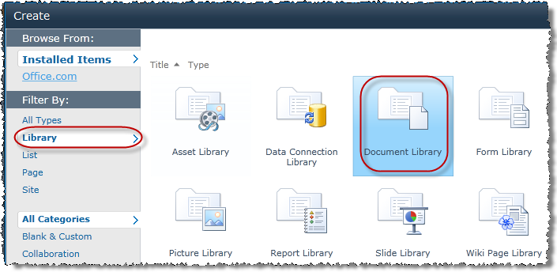

1. In the right pane of the window, the Document Library template name and description should appear. Read the template description then click the **More Options** button to customize the library creation values.
2. The left pane of the window should have changed from a listing of different template choice buttons to the options page for a new document library. Fill in the following values according to your team's needs:

**Name:** My Team Documents

**Description:** Library for {insert your first name}'s Team.

**Display this document library on the Quick Launch?** Yes

**Create a version each time you edit a file in this document library**? No

**Document Template:** Microsoft Word document

1. Click **Create** to finish creating the new site. After a brief progress pop-up the default view page of the new library will automatically load in the browser.
2. Click the **Create Column** button in the **Manage Views** group of the **Library** tab in the ribbon to add a custom column to the library.

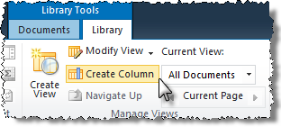

1. In the **Create Column** pop-up window enter the following values for your new column, taking the time to select each of the column types in turn and see their additional column settings before configuring the type dictated below:

**Name:** Origin

**Type:** Choice (menu to choose from)

**Description:** This column indicates whether the document is a native Wingtip document or imported from a Vendor.

**Require that this column contains information?** Yes

**Enforce unique values:** No

**Type each choice on a separate line:** Native; Import

**Display choices using:** Drop-Down Menu

**Allow 'Fill-in' choices?** No

**Default Value:** Choice -> <blank>

**Add to default view?** Checked

**Column Validation:** None

1. Click **OK** to finish creating the new column.
2. Repeat the previous steps create a second new column on the library. In the **Create Column** pop-up window enter the following values for the second new column:

**Name:** Internal

**Type:** Yes/No (checkbox)

**Description:** This column indicates whether the document is for Internal use only.

**Default value:** No

**Add to default view?** Checked

1. Click **OK** to finish creating the new column.
2. Verify that both of the new columns now appear on the default **All Documents** view of the library.

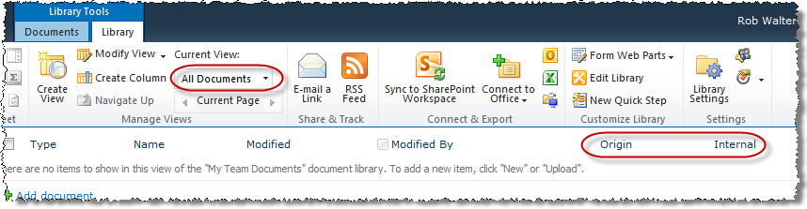

1. Populate the new library with some content:
2. Use Microsoft Word to create a new document named Wingtip History.docx, add some content and save it to your desktop.
3. Click the **Add document** link then **Browse** to select the **Wingtip History** document from the desktop, then click **Open**.
4. In the **Upload Document** pop-up click **OK** to upload the file.
5. In the resulting pop-up read the information banner then enter values of your choice for the missing metadata before clicking the **Save** button.
6. Verify that the Wingtip History document now appears in the library and is not checked out to you since you filled in all of the required metadata for the new item.



1. Enable Content Approval on the new library:
2. Click the **Library Settings** button in the **Settings** group of the **Library** tab in the ribbon.

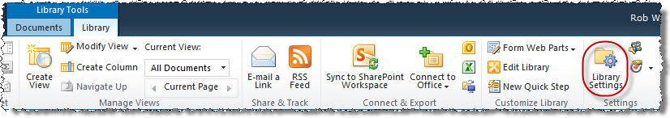

1. Click the **Title, Description and Navigation** link under the **General Settings** heading. Read the options but DO NOT alter any values. Click **Cancel** to return to the library settings.
2. Click the **Versioning Settings** link under the **General Settings** heading. Read all of the options then change **Content Approval** to **Yes** and click **OK** to save your changes.

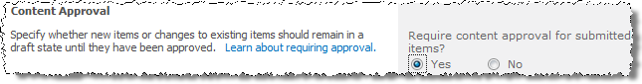

1. Read the remaining list of links available under the **General Settings** heading as well as the list of links available under the **Permissions and Management** heading to familiarize yourself with typical library level configuration settings but DO NOT alter any of them.
2. Return to the default **All Documents** view page of the new library via the breadcrumb trail. Notice that the existing documents that were already in the library have been automatically approved. This is because these items were added before changing the approval setting on the library.



1. Create a new document into the new library as Janice Galvin:
2. Authenticate into the library as Janice Galvin using the **Welcome Menu** in the top right corner and select **Sign in as Different User** and enter [[AD-DOMAIN]]\janice for the user name and click **OK**.
3. Click the drop-down arrow of the **New Document** button in the **New** group of the **Documents** tab in the ribbon and notice the icon of the **New Document** choice:

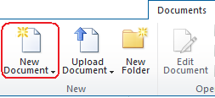

1. Click the **New Document** button in the drop-down and when Microsoft Word automatically launches add some content to the document. When the document loads, click the **Enable Editing** button below the ribbon.
2. Add some content to the document.
3. If you are using Word 2010, click the **File** tab to get to the **Backstage** of the document. In the right-hand part of the page you will find the required properties for the document:

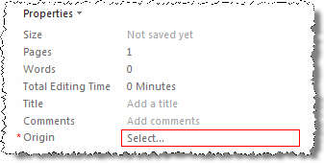

1. Click **Show All Properties** at the bottom of the right-hand panel to see all properties.
2. Enter a **Title**, **Origin** and **Internal** value of your choice into the fields then **Save** the document with a filename of JaniceDoc.docx and Exit Microsoft Word.
3. Back in the new library notice that Janice does not see her own new document. This is because content approval is required on this library.
4. Approve Janice’s new document as Rob.
5. Authenticate into the library as Rob Walters using the **Welcome Menu** in the top right corner and select **Sign in as Different User** and enter [[AD-DOMAIN]]\rob for the user name and click **OK**.
6. Verify that Janice’s new document appears in the library for Rob. This is because Rob has the authority to approve items for all libraries throughout the site that are inheriting their permissions from their parent.

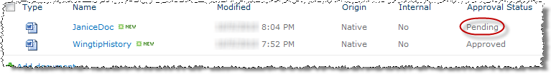

1. Check the select checkbox for JaniceDoc.docx and click the **Approve/Reject** button in the **Workflows** group of the **Documents** tab in the ribbon.

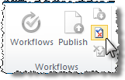

1. In the resulting pop-up, choose the **Approved** radio button and enter a few comments about how much you like Janice’s document, then click **OK** to approve the item.

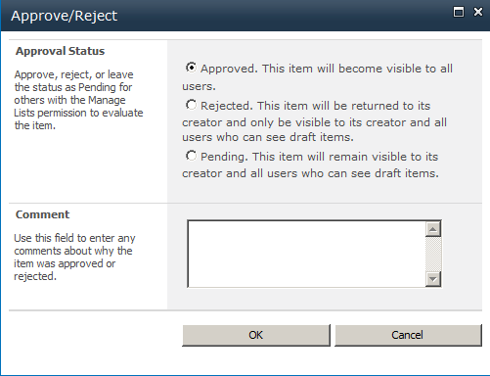

1. Back in the library verify that the **Approval Status** for JaniceDoc.docx changed automatically from **Pending** to **Approved**.
2. Verify Janice can see the new document:
3. Authenticate into the library as Janice Galvin using the **Welcome Menu** in the top right corner and select **Sign in as Different User** and enter [[AD-DOMAIN]]\janice for the user name and click **OK**.
4. Verify that Janice’s new document appears in the library for her now that it has been approved.
5. Authenticate into the library as Rob Walters using the **Welcome Menu** in the top right corner and select **Sign in as Different User** and enter [[AD-DOMAIN]]\rob for the user name and click **OK**.

In this exercise you learned to create a document library and configure its settings.

## Exercise 2: Creating Site Columns and Site Content Types

In this exercise you will practice creating and implementing Site Columns and Site Content Types.

1. Your team has expressed interest in having a "standard" column on all lists and libraries in your lab site that reflects which team member requested an item (not who created it, not who modified it, but who originally *requested* that it be created). This would help them determine the most prevalent users on the site. You are hesitant to put forth the effort to create a unique list-centric column on every existing list that is defined exactly the same way due to time constraints.
2. Click the **Site Actions** hyperlink in the upper left corner of the page.
3. Click the **Site Settings** link from the resulting Site Actions drop-down menu.
4. Click the **Site columns** link under the **Galleries** heading.
5. In the **Site Columns Gallery**, carefully read through the existing site columns' names and make sure there is not already a custom site column titled **Requested By** or anything close that might work (you shouldn't fine one).
6. Decide to create a new site column named **Requested By**.
7. Create the new site column:
8. Click **Create** on the toolbar at the top of the **Gallery** listing to begin creating a new site column.
9. On the **New Site Column** page enter the following values for the new site column:

**Name:** Requested By

**Type:** Person or Group

**Put this site column into:** Existing Group -> Custom Columns

**Description:** This column is used to tracking content requests on the {insert your first name}’s team.

**Require that this column contains information?** No

**Allow multiple selections:** Yes

**Allow selection of:** People Only

**Choose From:** All Users

**Show field:** Name *\*\*NOT\*\** ***Name (with presence)***

1. Click **OK** to finish creating the new site column.
2. Verify that a new **Group** header was created called **Custom Columns** and that your new **Requested By** site column appears below it.

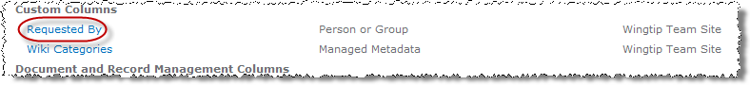

1. Return to the home page of your lab site via your preferred method for the next step.
2. Use the new **Requested By** site column on all existing user content lists and libraries:
3. Click **All Site Content** at the bottom of the Quick Launch Bar.
4. Click the **My Team Documents** document library created in the previous exercise of this lab.
5. Click the **Library Settings** button in the **Settings** group of the **Library** tab in the ribbon.
6. Scroll down to the **Columns** section and click the **Add from existing site columns** hyperlink at the bottom of the **Columns** section (beneath the list of column names).

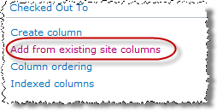

1. On the **Add Columns from Site Columns** page find the Requested By column and add it to the library.
2. Click **OK** to finish adding the **Requested By** site column to the library and verify that it now appears in the **Columns** section of the library settings.
3. Return to the home page of your site collection via your preferred method for the next step.
4. Several teams at Wingtip Toys, including your team, have need for a simple document template in their libraries that allows users to create new time off requests and print them out to be signed. As a pilot group, your team has volunteered to test the use of a content type for this purpose. Create a new site content type.
5. Click the **Site Actions** hyperlink in the upper left corner of the page.
6. Click the **Site Settings** link from the resulting Site Actions drop-down menu.
7. Click the **Site content types** link under the **Galleries** heading.
8. In the **Site Content Types Gallery**, carefully read through the existing site content types' names and make sure there is not already a content type called **time off request** or anything close that might work (you shouldn't fine one).
9. Click **Create** on the toolbar at the top of the **Gallery** listing to begin creating a new site content type.
10. On the **New Site Content Type** page enter the following values for the new site column:

**Name:** Time Off Request

**Description:** Choose this to create a new printable Time Off Request document.

**Parent Content Type:** Document Content Types > Document

**Put this site content type into:** Existing Group -> Custom Content Types

1. Click **OK** to finish creating the new site content type.
2. On the settings page for the new site content type enter the following values for your new Web Part page click the **Advanced Settings** hyperlink under the **Settings** section.
3. Using Microsoft Word, create a new file named Time Off Request.docx, add some content to it and save it to the desktop.
4. In the Document Template section, choose **Upload a new document template** and click **Browse**.
5. Find the Time Off Request.docx file on the desktop and click **Open**.
6. Back on the **Advance Settings** page leave the remaining settings their default values and click **OK** to configure the advanced settings of the content type.
7. Back on the content type settings page, scroll down to the **Columns** section and click the **Add from existing site columns** hyperlink.
8. On the **Add Columns to Content Type** page enter the following values to select a site column. Pick the **Requested By** column from the **Custom Columns** group and click **Add** followed by **OK**.
9. Use the **Navigate Up** icon to go back to the **Site Content Types** page to verify that a new **Group** header was created called **Custom Content Types** and that your new **Time Off Request** site content type appears below and its name is a hyperlink indicating that unlike the gray inherited site content types the new **Time Off Request** site content type was created here in this gallery and can be modified here in this gallery:

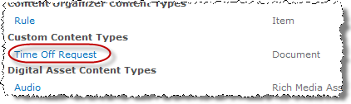

1. Navigate back to the home page of your lab site via the breadcrumb trail for the next step.
2. Use the new Time Off Request content type on a document library:
3. Navigate to the **My Team Documents** library by clicking the library's link in the Quick Launch Bar.
4. Click the **Library Settings** button in the **Settings** group of the **Document Tools »** **Library** tab in the ribbon.
5. Click the **Advanced Settings** hyperlink under the **General Settings** section.
6. Allow content type management by setting the value to **Yes** in the **Content Types** section the clicking **OK**.

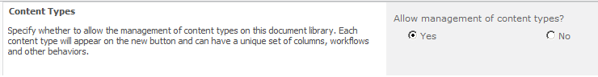

1. Back on the library settings page, scroll down to the new **Content Types** section and click the **Add from existing site content types** hyperlink.

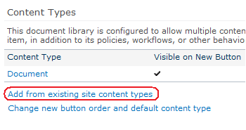

1. On the **Add Content Types** page find the **Time Off Request** content type in the **Custom Content Types** group and add it to the library. Then click **OK**.
2. Test the content type by returning to the library via the breadcrumb trail and clicking the **drop-down** menu of the **New Document** button in the **New** group of the **Documents** tab in the ribbon. **Time Off Request** should now be an option in the menu.

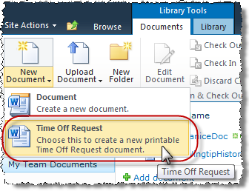

In this exercise you learned to create and employ Site Columns and Site Content Types.

## Exercise 3: Create Views and Securing Documents

In this exercise you will learn to create public views and assigning permissions to a list.

1. Your team would like a view of the **My Team Documents** library that everyone can use and that only displays the name of the document and who requested it. They would like the view to sort and group the items by requestor. Create the new view:
2. Click the **New View** button from the **Manage Views** group of the **Library Tools »** **Library** tab in the ribbon.

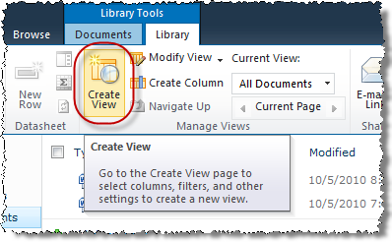

1. On the **Create View** page read all of the view format choices then click on **Standard View**. Use the following to create a new view:

**View Name:** By Requestor

**Make this the default view:** Unchecked

**View Audience:** Create a Public View

**Columns:** 1-Name (linked to document with edit menu); 2-Requested By

**Sort:** **Sort by the column-** Title

1. Click **OK** to finish creating the new view. The library should automatically switch to the new view.
2. Switch to any view other than the new **By Requester** view by clicking the drop-down menu under **Current View** in the **Manage Views** group of the **Library** tab in the ribbon and selecting the a different view.

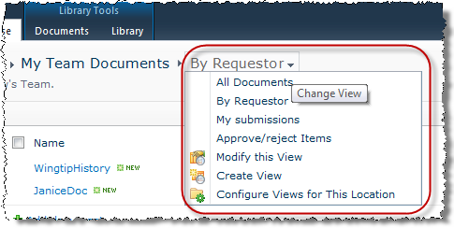

1. Your team would like to set unique permissions on the **My Team Documents** library so that Michael Sullivan can add, edit and delete items in addition to configuring item properties. Set the appropriate permissions on the list.
2. Click the **Library Settings** button in the **Settings** group of the **Library Tools » Library** tab in the ribbon.
3. Click on the **Permissions for this document library** link under the **Permissions and Management** section heading.

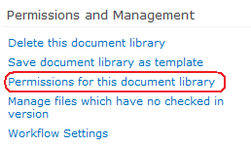

1. Click the **Stop Inheriting Permissions** button in the **Inheritance** group of the **Edit** tab in the ribbon.

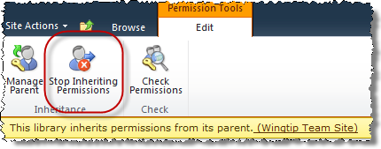

1. Click **OK** to the pop-up warning that permission changes made at the parent will no longer effect this library.

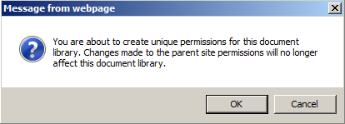

1. Click the **Members** group name hyperlink.

**Note**: The name of this group is different with each site. It is named **[Site Name] Members** in your site.

1. Notice that members who used to be getting inherited from the parent are explicitly defined at the library level.
2. On the Members group's page, click the **New** button in the list toolbar.

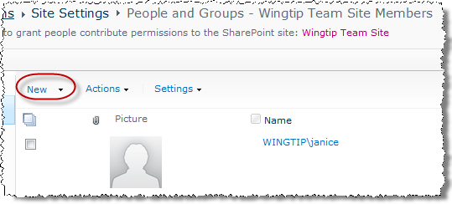

1. In the **Grant Permissions** pop-up, click the **Browse** icon in the lower right corner below the **Users/Groups** field.
2. In the resulting **Select People and Groups** pop-up window, type **Michael** into the **Find** field and click the magnifying glass button. All SharePoint person and group objects having names that start with **Michael** will appear in the results pane. Single-click to highlight **Michael Sullivan** and click the **Add->** button beneath the results pane to add Michael to the list of objects chosen from the find results. Click **OK** to add the Michael to the site's Members group.

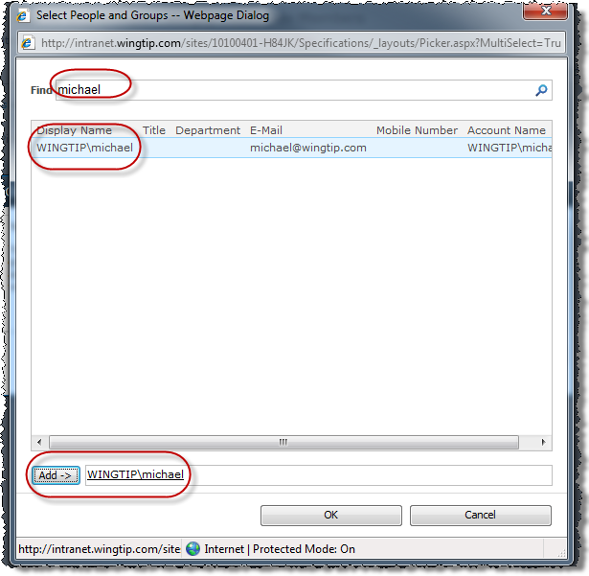

1. Verify that Michael has joined Michael as a member of your lab site:

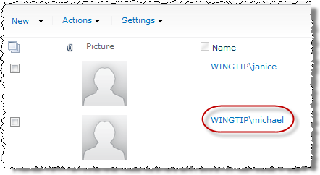

1. Return to the **My Team Documents** library by clicking the library's link in the Quick Launch Bar for the next step.
2. Your team would like to set unique permissions on the Wingtip History document in the **My Team Documents** library so that Michael Sullivan has no rights to the item at all. Set the appropriate permissions on the document:
3. Check the selection box of the **Wingtip History** item.

screenshot

1. Click on the **Document Permissions** button under the **Manage** group of the **Library Tools »** **Documents** tab in the ribbon.

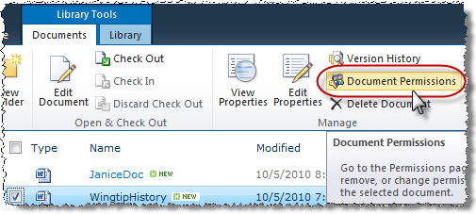

1. Click the **Stop Inheriting Permissions** button in the **Inheritance** group of the **Edit** tab in the ribbon. Click **OK** to the pop-up warning that permission changes made at the parent will no longer affect this document.
2. Click the **Visitors** group name hyperlink.
3. Check the selection box next to the Michael Sullivan member.
4. From the **Actions** button in the toolbar, choose to **Remove Users from Group** and click **OK** in the pop-up warning.

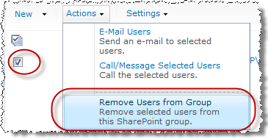

1. Click the **Members** group name hyperlink.
2. Check the selection box next to the Michael Sullivan member.
3. From the **Actions** button in the toolbar, choose to **Remove Users from Group** and click **OK** in the pop-up warning.
4. Return to the **My Team Documents** library by clicking the library's link in the Quick Launch Bar.
5. Test that Michael no longer sees the Wingtip History item:
6. Authenticate into the library as Mike Sullivan using the **Welcome Menu** in the top right corner and select **Sign in as Different User** and enter [[AD-DOMAIN]]\michaels for the user name and click **OK**.
7. Verify that the **Wingtip History** item does not appear in the library.

In this exercise you practiced creating view and setting permissions.